Arduino Night Make-i-stan

Simon Says

Source: [SparkFun](https://learn.sparkfun.com/tutorials/sik-experiment-guide-for-arduino---v32/experiment-16-simon-says)



Simon Says

Introduction

Now that we’ve learned all the basics behind the components in the SIK experiments, let’s put them all together to make some fun. This circuit will show you how to create your own Simon Says game. Using some LEDs, some buttons, a buzzer, and some resistors, you can create this and other exciting games with the RedBoard or Arduino Uno R3.

Parts Needed

You will need the following parts:

* **1x** Breadboard
* **1x** RedBoard or Arduino Uno
* **4x** LEDs
* **1x** Piezo Buzzer
* **4x** 330Ω Resistors
* **4x** Push Buttons
* **17x** Jumper Wires

### Hardware Hookup

Ready to start hooking everything up? Check out the Fritzing diagram below, to see how everything is connected.

|  |  |
| --- | --- |
| Polarized Components | Pay special attention to the component’s markings indicating how to place it on the breadboard. Polarized components can only be connected to a circuit in one direction. |

#### Fritzing Diagram for RedBoard

[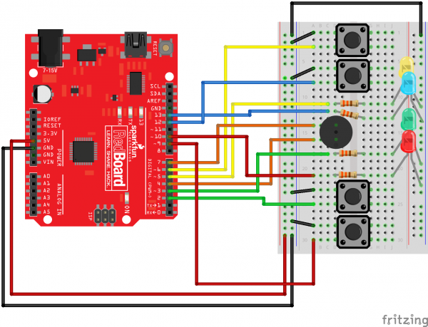](https://cdn.sparkfun.com/assets/learn_tutorials/3/1/0/RedBoard_circuit_16_01.png)

Having a hard time seeing the circuit? Click on the Fritzing diagram to see a bigger image.

#### Fritzing Diagram for Arduino

[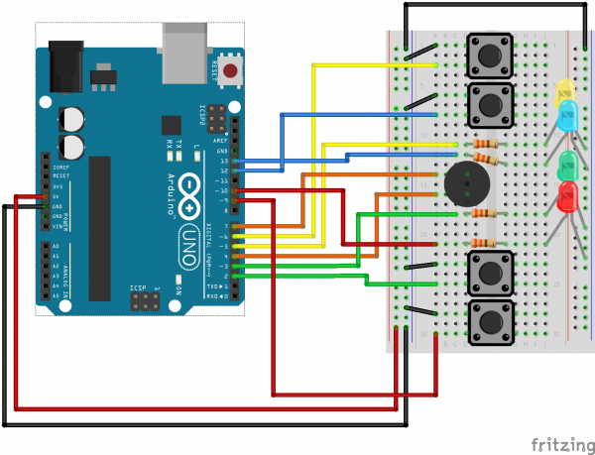](https://cdn.sparkfun.com/assets/learn_tutorials/3/1/0/Arduino_circuit_16_01.png)

### Open the Sketch

Open Up the Arduino IDE software on your computer. Coding in the Arduino language will control your circuit. Open the code for Circuit 16 by accessing the “SIK Guide Code” you downloaded and placed into your “Examples” folder earlier.

To open the code go to: **File > examples > SIK Guide Code > Circuit_16**

You can also copy and paste the following code into the Arduino IDE. Hit upload, and see what happens!

### Code to Note

#define

The #define statement is used to create constants in your code. Constants are variables that will likely only have one value during the lifespan of your code. Thus, you can assign constants a value, and then use them throughout your code wherever. Then, if you need to change that value, you can change that one line instead of going through all the code to find every instance of that variable.

byte

Bytes are another variable type. In the world of computing, a byte is a chunk of space that contains 8 bits, and a bit is a single binary value. Binary is another way of counting and uses only 1’s and 0’s. So a byte can hold all 1’s: 11111111, all 0’s: 00000000, or a combination of the two: 10010110.

### What You Should See

Once the code is uploaded, the buzzer will beep a few times, and all four LEDs should begin blinking. The game begins once you press any of the four buttons. Once the game has been started, a random LED will blink. Press the button associated with that color LED to replicate the pattern. With a successful guess, the pattern will repeat, this time adding another random LED. The player is to follow the pattern for as long as possible, with each successful guess resulting in an additional layer of complexity added to the original pattern.

[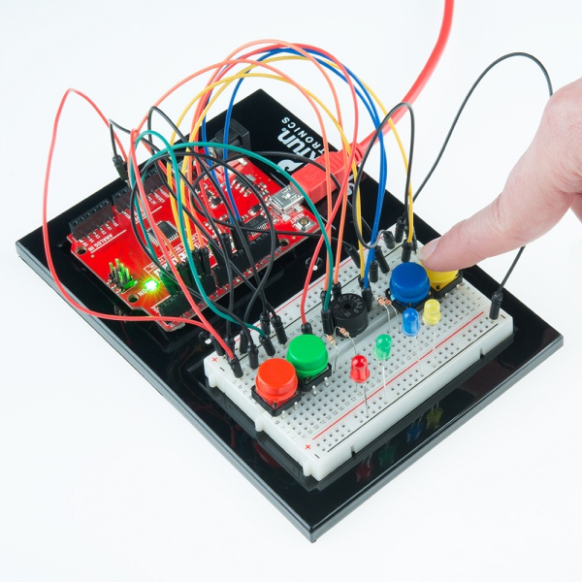](https://cdn.sparkfun.com/r/600-600/assets/learn_tutorials/3/1/0/SIK_RedBoard_exp_16_01.jpg)

[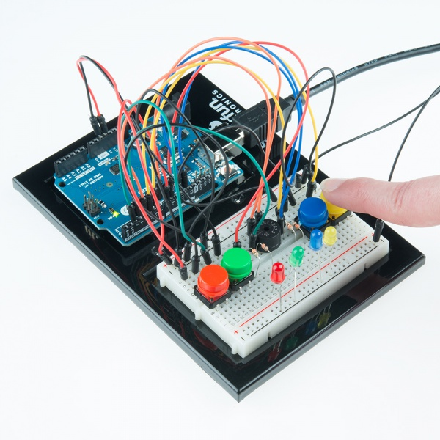](https://cdn.sparkfun.com/r/600-600/assets/learn_tutorials/3/1/0/SIK_Arduino_Uno_exp_16_01.jpg)

### Real World Application

Toys and Games, such as the original Simon from Milton Bradley, have relied on electronics to provide fun and entertainment to children across the world.

### Troubleshooting

#### Only Half the Circuit Works

If only half of you circuit is working, make sure you added the additional wire from one ground rail to the other. Remember that breadboards have two power rails on each side and that these can be connected, or bussed, together to provide the power to both sides of the same circuit.

#### No Sound

Once the piezo buzzer is in the breadboard, it’s hard to see the legs and to which row they are connected. If you aren’t hearing any sound, make sure your wires are on the same row as the piezo buzzer legs.

#### Game is Not Working

If everything starts up ok, but you’re having trouble when it comes time to play the game, you may have a button or two misplaced. Pay close attention to which pin is connected to each button as it matters which button is pressed when a particular color lights up.